Equal-Base Spherical Segment
# Source: AI Source: Provided by: [Data Path: Persons Table -> ID Column: 1, Name_En Column: Motasem Essam] -> From: [ChatGPT] on [7/25/2026]
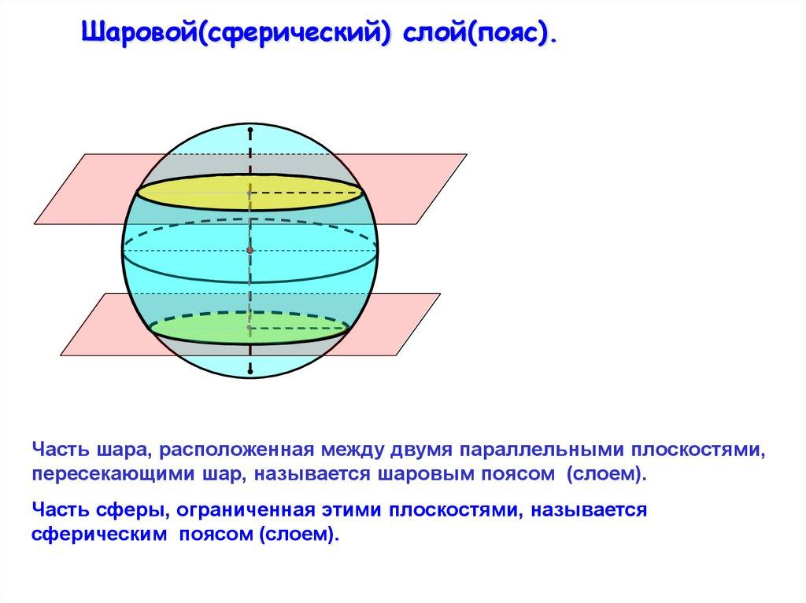

Definition
# Source: AI Source: Provided by: [Data Path: Persons Table -> ID Column: 1, Name_En Column: Motasem Essam] -> From: [ChatGPT] on [7/25/2026]
An equal-base spherical segment is a portion of a solid sphere bounded by two parallel planes that intersect the sphere in two circular bases of equal radius.
For a sphere of radius $R$, the two base circles have equal radii when their cutting planes are equally distant from the sphere's center. The segment's curved boundary is part of the sphere's surface.
When the two planes are distinct and symmetrically positioned on opposite sides of the center, the segment is centered on the sphere's equatorial plane.

Simple Definition
# Source: AI Source: Provided by: [Data Path: Persons Table -> ID Column: 1, Name_En Column: Motasem Essam] -> From: [ChatGPT] on [7/25/2026]
An equal-base spherical segment is a slice of a sphere between two parallel planes that creates two circular bases of the same size.

Geometric Elements
# Source: AI Source: Provided by: [Data Path: Persons Table -> ID Column: 1, Name_En Column: Motasem Essam] -> From: [ChatGPT] on [7/25/2026]
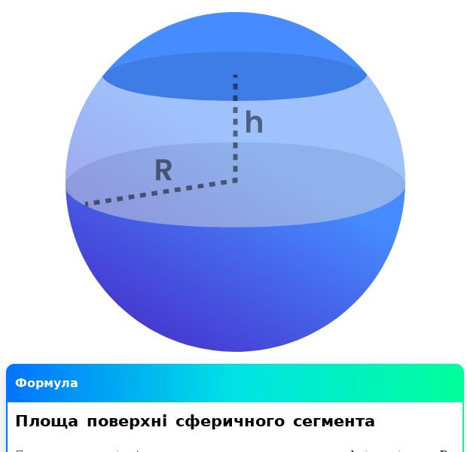
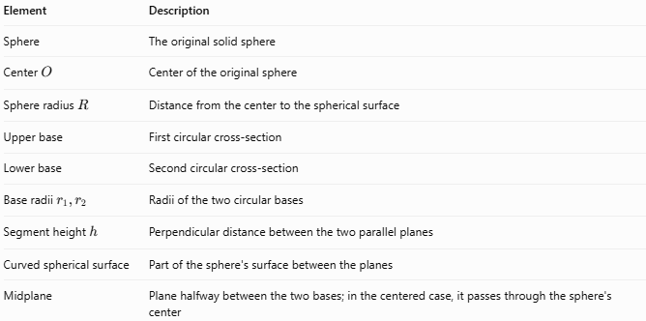
Element | Description
Sphere | The original solid sphere
Center $O$ | Center of the original sphere
Sphere radius $R$ | Distance from the center to the spherical surface
Upper base | First circular cross-section
Lower base | Second circular cross-section
Base radii $r_{1},r_{2}$ | Radii of the two circular bases
Segment height $h$ | Perpendicular distance between the two parallel planes
Curved spherical surface | Part of the sphere's surface between the planes
Midplane | Plane halfway between the two bases; in the centered case, it passes through the sphere's center
Important distinction: Equal base radii do not always mean the planes are symmetrically positioned about the center. The planes can lie on the same side of the center at equal absolute distances from it only if they coincide. For two distinct parallel planes cutting the same sphere, equal radii imply equal and opposite signed distances from the center.

Mathematical Properties and Formulas
# Source: AI Source: Provided by: [Data Path: Persons Table -> ID Column: 1, Name_En Column: Motasem Essam] -> From: [ChatGPT] on [7/25/2026]
Let:
- $R$ = radius of the original sphere
- $r$ = common radius of both circular bases
- $h$ = distance between the parallel planes
- $V$ = volume of the spherical segment
- $A_{c}$ = curved surface area
- $A_{t}$ = total surface area, including both circular bases

Equal-Base Condition
# Source: AI Source: Provided by: [Data Path: Persons Table -> ID Column: 1, Name_En Column: Motasem Essam] -> From: [ChatGPT] on [7/25/2026]
$$\boxed{r_{1}=r_{2}=r}$$
For two distinct parallel cutting planes in a sphere, their signed distances from the center must be equal in magnitude and opposite in sign.
If each plane is at distance $d$ from the center:
$$\boxed{r=\sqrt{R^{2}-d^{2}}}$$

Height
# Source: AI Source: Provided by: [Data Path: Persons Table -> ID Column: 1, Name_En Column: Motasem Essam] -> From: [ChatGPT] on [7/25/2026]
For a segment centered on the sphere's center:
$$\boxed{h=2d}$$
Because each plane is at distance $d$ from the center, the distance between them is $2d$.

Volume
# Source: AI Source: Provided by: [Data Path: Persons Table -> ID Column: 1, Name_En Column: Motasem Essam] -> From: [ChatGPT] on [7/25/2026]
The general spherical-segment formula is
$$V=\frac{πh}{6}\left(3r_{1}^{2}+3r_{2}^{2}+h^{2}\right)$$
For equal bases, substitute $r_{1}=r_{2}=r$:
$$\boxed{V=πh\left(r^{2}+\frac{h^{2}}{6}\right)}$$
Equivalently,
$$\boxed{V=πhr^{2}+\frac{πh^{3}}{6}}$$

Curved Surface Area
# Source: AI Source: Provided by: [Data Path: Persons Table -> ID Column: 1, Name_En Column: Motasem Essam] -> From: [ChatGPT] on [7/25/2026]
$$\boxed{A_{c}=2πRh}$$

Total Surface Area
# Source: AI Source: Provided by: [Data Path: Persons Table -> ID Column: 1, Name_En Column: Motasem Essam] -> From: [ChatGPT] on [7/25/2026]
The total surface area includes the curved surface and two circular bases:
$$A_{t}=2πRh+2πr^{2}$$
Therefore,
$$\boxed{A_{t}=2π\left(Rh+r^{2}\right)}$$

Worked Example
# Source: AI Source: Provided by: [Data Path: Persons Table -> ID Column: 1, Name_En Column: Motasem Essam] -> From: [ChatGPT] on [7/25/2026]
A sphere has radius $R=10\text{ cm}$. Two parallel planes are placed $6\text{ cm}$ on either side of the sphere's center. Calculate the base radius, segment height, volume, curved surface area, and total surface area.
Given
$$R=10\text{ cm}, d=6\text{ cm}$$
Step 1 — Calculate the common base radius
$$\begin{aligned}r&=\sqrt{R^{2}-d^{2}} \\ &=\sqrt{{10}^{2}-6^{2}} \\ &=\sqrt{64}=8\end{aligned}$$
$$\boxed{r=8\text{ cm}}$$
Both circular bases have radius $8\text{ cm}$.
Step 2 — Calculate the segment height
$$h=2d=2\left(6\right)=12\text{ cm}$$
$$\boxed{h=12\text{ cm}}$$
Step 3 — Calculate the volume
$$\begin{aligned}V&=πh\left(r^{2}+\frac{h^{2}}{6}\right) \\ &=π\left(12\right)\left(64+\frac{144}{6}\right) \\ &=12π\left(88\right) \\ &=1056π\end{aligned}$$
$$\boxed{V≈3317.52{\text{ cm}}^{3}}$$
Step 4 — Calculate the curved surface area
$$A_{c}=2πRh=2π\left(10\right)\left(12\right)=240π$$
$$\boxed{A_{c}≈753.98{\text{ cm}}^{2}}$$
Step 5 — Calculate the total surface area
$$\begin{aligned}A_{t}&=2π\left(Rh+r^{2}\right) \\ &=2π\left(120+64\right) \\ &=368π\end{aligned}$$
$$\boxed{A_{t}≈1156.11{\text{ cm}}^{2}}$$

Comparison with Related Solids
# Source: AI Source: Provided by: [Data Path: Persons Table -> ID Column: 1, Name_En Column: Motasem Essam] -> From: [ChatGPT] on [7/25/2026]
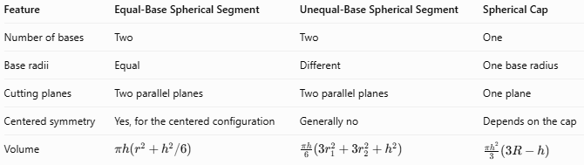
Feature | Equal-Base Spherical Segment | Unequal-Base Spherical Segment | Spherical Cap
Number of bases | Two | Two | One
Base radii | Equal | Different | One base radius
Cutting planes | Two parallel planes | Two parallel planes | One plane
Centered symmetry | Yes, for the centered configuration | Generally no | Depends on the cap
Volume | $$πh\left(r^{2}+h^{2}/6\right)$$ | $$\frac{πh}{6}\left(3r_{1}^{2}+3r_{2}^{2}+h^{2}\right)$$ | $$\frac{πh^{2}}{3}\left(3R-h\right)$$

Applications
# Source: AI Source: Provided by: [Data Path: Persons Table -> ID Column: 1, Name_En Column: Motasem Essam] -> From: [ChatGPT] on [7/25/2026]
- Engineering: Calculating the volume of spherical sections with equal circular ends.
- Manufacturing: Designing and measuring spherical components and curved parts.
- Architecture: Modeling spherical bands and sections of domes.
- Fluid storage: Estimating contents in a spherical vessel between two parallel levels.
- Computer-aided design: Building symmetrical spherical sections in CAD models.
- Mathematics: Studying symmetry, sphere-plane intersections, and solid-volume formulas.

Key Points
# Source: AI Source: Provided by: [Data Path: Persons Table -> ID Column: 1, Name_En Column: Motasem Essam] -> From: [ChatGPT] on [7/25/2026]
- An equal-base spherical segment has two circular bases with the same radius.
- For two distinct parallel planes cutting a sphere, equal base radii mean the planes are equally distant from the center on opposite sides.
- Its height is the perpendicular distance between the planes.
- The volume formula simplifies because both base radii are equal.
- Its curved surface area is $2πRh$.
- Its total surface area includes both circular bases.
- A segment centered on the sphere is symmetric about its center and equatorial plane.

Conclusion
# Source: AI Source: Provided by: [Data Path: Persons Table -> ID Column: 1, Name_En Column: Motasem Essam] -> From: [ChatGPT] on [7/25/2026]
An Equal-Base Spherical Segment is a portion of a sphere bounded by two parallel planes that produce circular bases of equal radius. In its centered configuration, the planes lie symmetrically on opposite sides of the sphere's center. This geometry makes it useful for studying symmetric spherical sections and calculating their volumes and surface areas.

